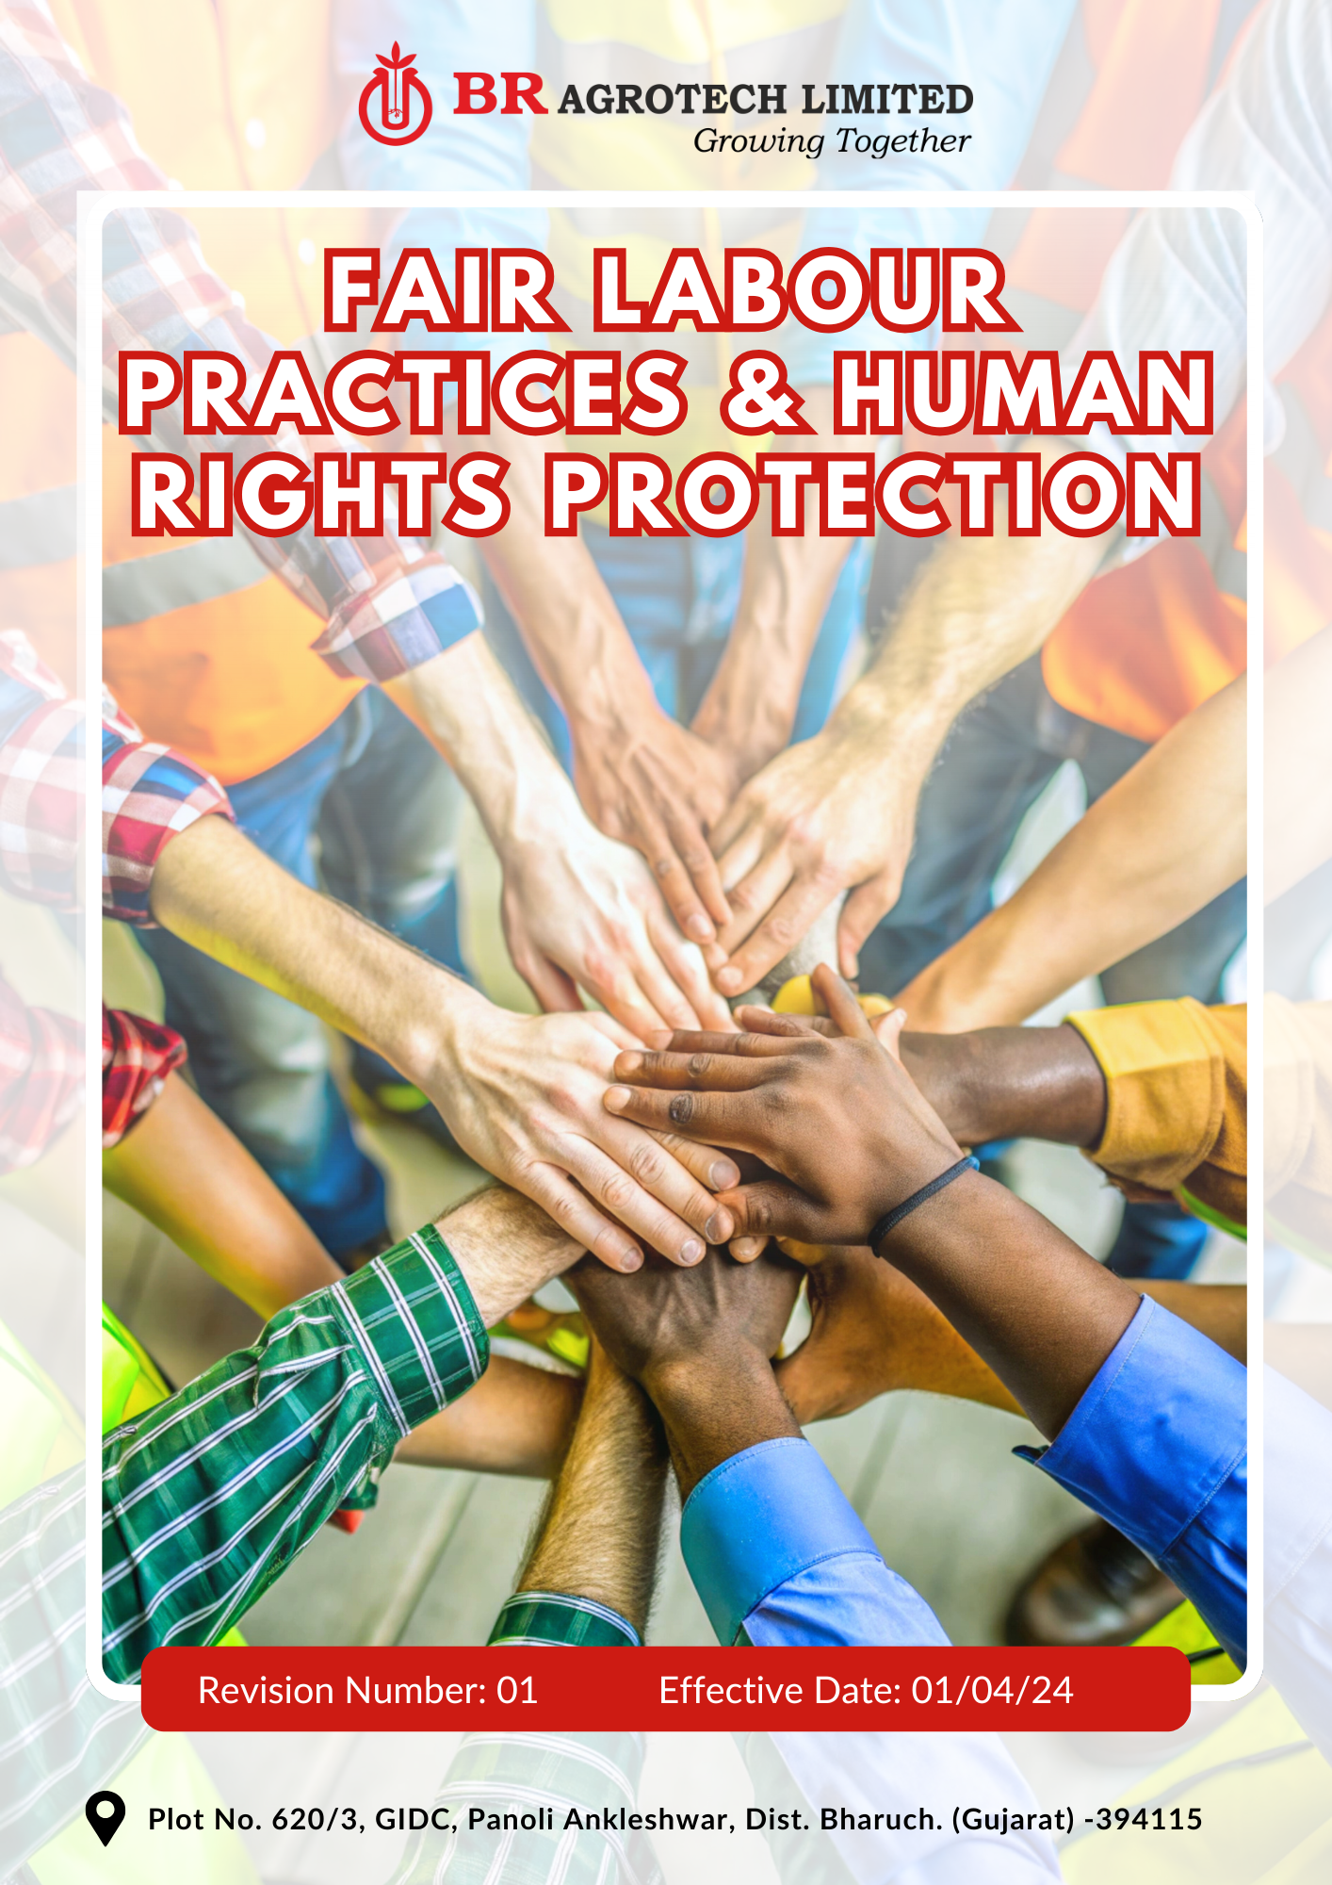
Contents

Preface 3
Policy Declaration 3
Scope 3
Our Commitments 4
Our Performance Targets 4
Alignment with the United Nations Sustainable Development Goals (SDGs) 5
Responsibilities 6
Monitoring, Reporting, and Review Mechanism 7
Employee Acknowledgment Form 8

Preface
BR Agrotech Limited fosters a workplace that prioritizes fairness, safety, and inclusivity. We recognize that ethical labor practices and human rights protection are essential to ensuring the well-being of employees, building trust with stakeholders, and maintaining business sustainability. By adhering to international labor standards and best practices, we aim to create a work environment that upholds dignity, equality, and respect for all.
This policy establishes our commitments to workplace safety, fair wages, equal opportunities, and non-discrimination while ensuring compliance with national and international labor regulations. Through proactive engagement, regular monitoring, and continuous improvement, we work towards strengthening our labor practices, eliminating any form of workplace exploitation, and fostering a culture of accountability and inclusivity.

Policy Declaration
BR Agrotech Limited is committed to fair labor practices and the protection of human rights in all aspects of its operations. We adhere to the International Labour Organization (ILO) standards, ensuring a safe, inclusive, and respectful workplace for all employees and stakeholders. This policy reinforces our dedication to ethical labor practices, equitable working conditions, and compliance with national and global labor laws.

Scope
This policy applies to BR Agrotech Limited’s operations, and it covers following sites and all its employees, workers, subcontractors and other stakeholders:

Site | Address
BR Agrotech  Limited | Plot No. 620/3, GIDC, Panoli Ankleshwar, Dist. Bharuch. (Gujarat)- 394 115

Our Commitments
- Maintain a safe and healthy work environment.
- Ensure fair wages, reasonable working hours, and a workplace free from discrimination or harassment.
- Promote open communication between employees and management.
- Offer equal opportunities for skill development, training, and career growth.
- Enforce a zero-tolerance policy and conduct supplier audits to ensure compliance.
- Foster an inclusive workplace with equal opportunities and fair representation.
- Respect employees' rights to form and join trade unions or other worker organizations.
- Ensure that hiring practices are transparent, free from discrimination, and compliant with labor laws.
- Prohibit retaliation against employees who report workplace grievances or unethical practices.
- Provide adequate employee benefits, including health insurance, maternity/paternity leave, and other social protections.
- Ensure ethical labor practices across supply chains through due diligence and engagement.

Our Performance Targets
All performance targets outlined in this policy use FY 2022-23 as the baseline year, serving as a reference point to measure progress, track improvements, and ensure accountability in achieving our labor and human rights goals.
- Enhance employee well-being by introducing stress management workshops and strengthen workplace safety culture by conducting regular risk assessments and implementing proactive hazard prevention measures.
- Maintain zero workplace incidents till FY 2029-30 through targeted training, risk mitigation strategies and hence maintain compliance with occupational health and safety standards across all operations.
- Strictly follow Anti-Discrimination measures and maintain fair wages and working hours in line with national labor laws
- Conduct annual employee satisfaction surveys with 80% positive response rate on workplace conditions by FY 2029-30.
- Conduct annual anti-harassment & anti-discrimination training for 100% of employees.
- Maintain structured communication framework to promote transparent discussions between employees and management.
- Ensure implementation of structured grievance mechanisms across all sites and to address 100% grievances within the designated resolution timeline by FY 2029-30.
- Introduce leadership development programs to prepare employees for managerial roles.
- To follow structured training framework to support employee skill enhancement and career progression.
- Ensure 30% of employees receive upskilling opportunities aligned with industry advancements by FY 2029-30.
- Maintain zero tolerance for child labor and forced labor through stringent monitoring and ethical sourcing policies.
- Conduct supplier audits annually to ensure full compliance with child and forced labor regulations.
- Train 100% of procurement and supply chain personnel on ethical sourcing and forced labor risks by FY 2029-30.
- Increase the female workforce representation by 15% and ensure equitable leadership representation by FY 2029-30.
- Focus on inclusive hiring practices and equal growth opportunities for underrepresented groups.
- Implement 3 mentorship and leadership development programs to foster diverse talent representation in senior roles by FY 2029-30.
- To strengthen due diligence mechanisms to ensure suppliers adhere to human rights and fair labor practices.
- Collaborate with 3 NGOs by FY 2029-30 to promote ethical labor standards.
- Expand employee welfare programs, including health insurance, parental leave, and financial wellness initiatives.
- Increase employee participation in benefits programs by 25% by FY 2029-30.

Alignment with the United Nations Sustainable Development Goals (SDGs)
The sustainability commitments and performance targets align with the following Sustainable Development Goals (SDGs):
- SDG 3: Good Health and Well-being – Workplace safety, stress management programs, health insurance, and employee well-being initiatives.
- SDG 5: Gender Equality – Female workforce representation, leadership opportunities for women, and inclusive hiring practices.
- SDG 8: Decent Work and Economic Growth – Fair wages, compliance with labor laws, skill development, elimination of child and forced labor, and improving working conditions.
- SDG 10: Reduced Inequalities – Equal growth opportunities, anti-discrimination measures, and leadership representation for underrepresented groups.
- SDG 16: Peace, Justice, and Strong Institutions – Strengthened due diligence, supplier audits, ethical sourcing, grievance mechanisms, and collaborations with NGOs.
- SDG 17: Partnerships for the Goals – Collaborating with NGOs and industry partners to promote ethical labor practices and responsible business conduct.

Responsibilities
- Site Head : Ensure implementation of fair labor policies and allocate resources for employee well-being. Implement workplace safety and ethical labor standards.
- Human Resources Team: Monitor labor conditions, oversee training programs, and address grievances.
- Supply Chain & Procurement: Ensure responsible sourcing and compliance with supplier labor policies.
- Employees: Adhere to workplace policies, report concerns, and participate in training initiatives.
- External Stakeholders: Support labor and human rights initiatives through responsible business practices.

Monitoring, Reporting, and Review Mechanism
- The Human Resources Team will track key labor and human rights indicators, conduct regular internal assessments, and report progress annually to senior management and relevant stakeholders. These reports will provide insights into compliance status, areas for improvement, and corrective actions taken to ensure continuous adherence to labor and human rights standards.
- Independent third-party audits and assessments are conducted periodically to validate compliance with labor regulations, identify gaps, and recommend improvements. These assessments will also help strengthen accountability and transparency in labor practices.
- This policy will be reviewed once in the two years or as needed by the Site Head to integrate emerging best practices, align with updated labor laws, and ensure continuous improvement in fair labor standards. Any necessary amendments will be approved by senior management and communicated to all employees and stakeholders.

Effective Date | : 01.04.2024
Next Review Date | : 01.04.2026
Revision No. | : 01

Approved By:

Employee Acknowledgment Form
I acknowledge that I have read, understood, and agree to comply with the Fair Labor Practices and Human Rights Protection Policy of BR Agrotech Limited. I understand my responsibilities in upholding fair labor standards, promoting a safe and inclusive workplace, and adhering to all applicable laws and company policies. I further agree to report any violations of this policy through the appropriate channels and actively participate in training and awareness programs related to labor rights and workplace ethics.

Employee Name | : _________________________
Employee ID | : _________________________
Department | : _________________________
Signature | : _________________________

